Q-1. Deploy a website on localhost using either apache2 or Nginx. Create a DNS name for this website as ‘awesomeweb’. You can use any web template you want or can write your own simple HTML code.

Write the detailed documentation with the steps involved.

Deploying a Website on Localhost using Nginx

Step 1: Install Nginx

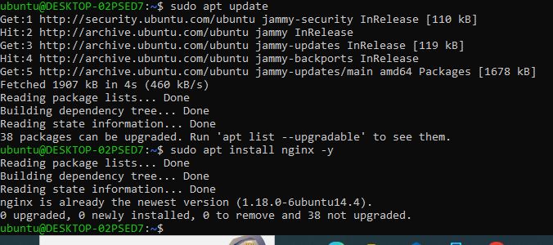

Step 2: Verify Nginx Installation

Open a web browser and navigate to http://localhost/. You should see the Nginx default page if the installation was successful.

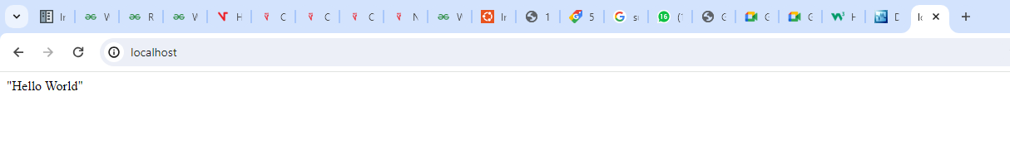

Step 3: Create Website Directory



Step 4: Create a simple HTML page. Add the following code to HTML file – index.html

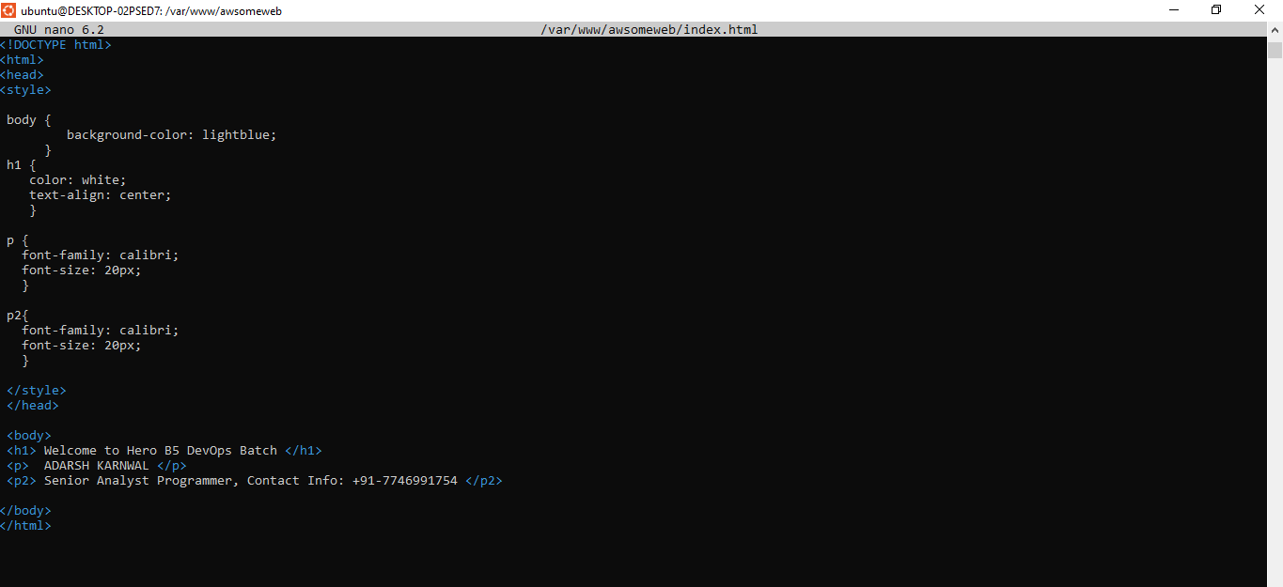

Step 5: Set permissions

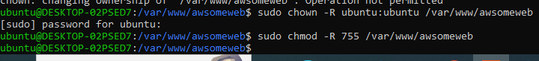

Step 6: Create nginx configuration. 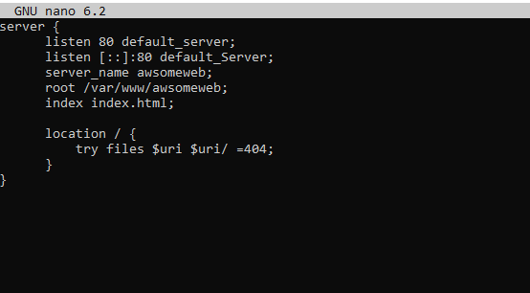

Step 7: Enable the website



Step 8: Test Nginx configuration



Step 9: Restart nginx



Step 10: Edit Hosts file



Add the following line at the end of the file. Save and close.



Step 11: Open the browser and test the website, navigate to <http://awsomeweb/>

Q-2. A website can have many subdomains and different services are running on them. Write a

Python script to check the status of the subdomains which are up or down. The script should

automatically check the status every minute and should update it in tabular format on the

screen.

Write documentation of it.

GITHUB Repository Link - <https://github.com/ada7git/gradedass_networking>

Task 3:

Virtual Machine (VM) - Overview

A virtual machine (VM) is a software emulation of a physical computer that runs an operating

system and applications just like a physical machine. VMs allow you to create multiple isolated

environments on a single physical host, each with its own virtual hardware configuration. This

virtualization technology provides several advantages, such as the ability to run multiple

operating systems on a single physical machine, easy migration of VMs between different hosts,

and improved resource utilization.

The virtualization layer called the hypervisor, is responsible for managing the VMs and enabling

communication between them and the underlying physical hardware. There are two types of

hypervisors: Type 1 hypervisor (bare-metal) runs directly on the physical hardware, while Type 2

hypervisor runs on top of an existing operating system.

Oracle VirtualBox - Overview

Oracle VirtualBox is a popular Type 2 hypervisor that allows you to create and manage virtual

machines on your desktop or laptop. It supports a wide range of guest operating systems,

including Windows, Linux, macOS, and more. VirtualBox is free and open-source, making it an

excellent choice for developers, testers, and anyone interested in exploring virtualization.

How to Install VirtualBox

Here's a step-by-step guide to installing Oracle VirtualBox on your Windows, macOS, or Linux

computer:

Step 1: Download VirtualBox

1. Go to the official VirtualBox website: https://www.virtualbox.org/

2. Click on the "Downloads" link in the top navigation menu.

Step 2: Choose the Correct Package

1. On the Downloads page, you'll see various packages for different host operating systems.

Select the appropriate package for your OS (e.g., Windows, macOS, or Linux).

Step 3: Install VirtualBox

1. For Windows:

- Download the installer for Windows and double-click on the downloaded file to start the

installation.

- Follow the on-screen instructions and accept the license agreement. - Choose the components

you want to install and the installation path. - Complete the installation process.

2. For macOS:

- Download the macOS version of VirtualBox.

- Double-click on the downloaded DMG file to open it.

- Double-click on the VirtualBox package icon to start the installation. - Follow the on-screen

instructions to complete the installation.

3. For Linux:

- Download the appropriate package for your Linux distribution (e.g., .deb for

Debian/Ubuntu-based systems, .rpm for Red Hat/Fedora-based systems). - Install VirtualBox

using the package manager of your Linux distribution. For example, for Ubuntu, use the

following command in the terminal:

sudo dpkg -i <VirtualBox_package_name>.deb

- You may need to install additional dependencies if prompted by the package manager.

Step 4: Post-installation Configuration (All Operating Systems)

1. After installation, you might need to add your user account to the "vboxusers" group (Linux) or

"VirtualBox Users" group (Windows) to grant permissions to manage VMs.

Step 5: Launch VirtualBox

1. Once the installation is complete, you can launch VirtualBox from your application menu

(Windows and Linux) or from the Applications folder (macOS).

Congratulations! You now have Oracle VirtualBox installed on your computer and can start

creating and managing virtual machines for various purposes, including development, testing,

and exploration of different operating systems.

Once the VM has been installed, visit https://www.osboxes.org/ download a Ubuntu 22.04 image

and start it through your VirtualBox.

Install Nginx inside the Ubuntu machine and host a website.

Come back to your host machine (windows/Linux/mac) and scan the virtual machine using

nmap. Create the documentation of the process and the output of the scan. Observe the ports

which are open.

Step 1: Install Oracle VirtualBox on Windows 11

Download VirtualBox

● Visit the official VirtualBox website: VirtualBox Download

● Click on the "Downloads" link in the top navigation menu.

● Download the Windows installer.

Install VirtualBox

● Double-click on the downloaded .exe file to start the installation.

● Follow the on-screen instructions, accept the license agreement, and choose the

components and installation path.

● Complete the installation process.

Step 2: Download Ubuntu 22.04 Image

● Visit OSBoxes

● Go to OSBoxes Ubuntu 22.04 Download

● Download the Ubuntu 22.04 image compatible with VirtualBox.

Step 3: Set Up Ubuntu VM in VirtualBox

Create a New VM

● Open VirtualBox.

● Click on "New" to create a new VM.

● Name your VM and select "Linux" as the type and "Ubuntu (64-bit)" as the

version.

● Allocate memory.

● Choose "Create a virtual hard disk now" and follow the steps to allocate disk

space.

Configure VM Settings

● Select your new VM and click on "Settings."

● Under "Storage," add the downloaded Ubuntu 22.04 image by clicking on the

empty optical drive and choosing the disk file.

Network Settings

● Go to the "Network" tab.

● In the "Attached to" dropdown menu, select "Bridged Adapter".

● Choose the appropriate network interface from the "Name" dropdown menu.

● Click "OK" to save the settings.

Start the VM

● Start the VM by selecting it and clicking "Start."

● The OS will be loaded with preconfiguration.

● The login password of the user osboxes.org will be osboxes.org

Step 4: Install Nginx and Host a Website on Ubuntu VM.

Update the System

● Open the terminal in the Ubuntu VM.

● Run the following commands to update the package list and upgrade the system:

sudo apt update

sudo apt upgrade -y

Install Nginx

sudo apt install nginx -y

Start the Nginx service and enable it to run on boot:

sudo systemctl start nginx

sudo systemctl enable nginx

Create a simple HTML file to host:

echo "<html>

<body>

<h1>Adarsh Karnwal Devops Batch 5 </h1>

</body>

</html>" | sudo tee /var/www/html/index.html

Verify Nginx

● Open a web browser and go to the IP address of the Ubuntu VM. You should see

the message "Adarsh Batch 5"

Step 5: Scan the Virtual Machine Using Nmap

Install Nmap on Host Machine

● Download and install Nmap from the official website.

● Follow the installation instructions for Windows.

Find the IP Address of the Ubuntu VM

In the Ubuntu VM, run the following command to find the IP address:

sudo apt-get install net-tools -y

ifconfig

Run Nmap Scan

● Open the command prompt on the host machine.

● Run the following command to scan the Ubuntu VM:

nmap -sS [Ubuntu_VM_IP]

Step 6: Document the Nmap Scan Output

Sample Nmap Output

Starting Nmap 7.92 ( https://nmap.org ) at 2024-05-17 09:33 EDT

Nmap scan report for osboxes (10.0.0.135)

Host is up (0.00012s latency).

Not shown: 999 closed ports

PORT STATE SERVICE

80/tcp open http

Nmap done: 1 IP address (1 host up) scanned in 1.23 seconds

Observation

Ports 80 (HTTP) is open.

This indicates that Nginx is properly configured and accessible.